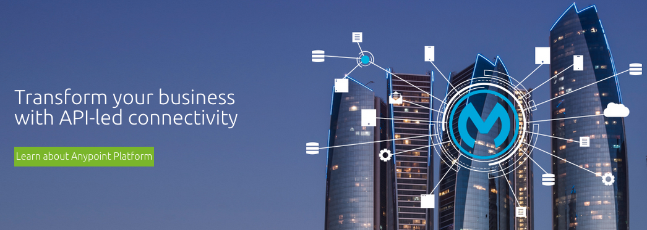

**Anypoint Platform**

API Led Connectivity Workshop

This page intentionally blank.

**Anypoint Platform**

API Led Connectivity Workshop

[Why API Led Connectivity?](#_ugce8xwcohum)

[Mobility Delivered Through API-Led Connectivity](#_xz4uim62zacr)

[Before You Begin](#_2b3qlwqp6j59)

[General Notes](#_3znysh7)

[Connecting to your Workshop Instance](#_lmi58haew7n3)

[Workshop Labs](#_gmjh79bw253f)

[End to End API Management](#_bwxomorbdlf1)

[Lab 1: Proxy an existing API](https://docs.google.com/document/d/1lHlLBeonjGI8vAvuyQ3mP_maZ_n_2601XLUULSX8rP0/edit?usp=sharing)

[Lab 2: Manage and Consume the API](https://docs.google.com/document/d/1vAaHskq9To2OOn3V8W8txlTvL2UXBQwp-Phr-pNDtMg/edit?usp=sharing)

[Lab 3: Monitor the API](https://docs.google.com/document/d/137X6zOmDuyb_dLvt4jgKk3-c_ypf3CyxaVbKNU_8E88/edit?usp=sharing)

[API Design First Approach](#_juf6src0nr3b)

[Lab 4: Design a new API with RAML](https://docs.google.com/document/d/14DrjVd_RBykOGX11uVktQdlqnS_gYSJueKdKuz3yOLQ/edit?usp=sharing)

[Lab 5: Create an API Portal](https://docs.google.com/document/d/1EM-jqP2m1hLk2fVg9KQ93-57QKHqthfR4ea5odD0ZVE/edit?usp=sharing)

[Lab 6: Generate your API Project from the RAML Design](https://docs.google.com/document/d/1E5fbJygIY3OD1V3Mu0w-QKWwpn-pa-8XTeMgnB0u4LY/edit?usp=sharing)

[Enterprise Connectivity and Orchestration](#_b7sxfzls0sbp)

[Lab 7: Connect to a System API](https://docs.google.com/a/mulesoft.com/document/d/1jK1bPQ1kJzAJCh4VXTKw_GuxaV6i-mE-UfE8JtIjeRE/edit?usp=sharing)

[Lab 8: Orchestrate REST and JMS endpoints](https://docs.google.com/a/mulesoft.com/document/d/1jGi62ffpgCKUOGzGaNlrHgZbuTjmuYLCACrAoSD8KQk/edit?usp=sharing)

[Lab 9: Orchestrate SOAP and Database Endpoints](https://docs.google.com/a/mulesoft.com/document/d/1dxHM6pnjzcrFelcZXP4uHlQfgHz_CUwRsxmXBxYtaDI/edit?usp=sharing)

[Hybrid Cloud Integration](#_14w3q03grmod)

[Lab 10: Connect to External SaaS and Social Networks](https://docs.google.com/document/d/1ybvjhlsR0kPMV_2o3y-Inv7Ik3g4Ix_Tps7QhhOfF8o/edit?usp=sharing)

[Lab 11: Hybrid Integration and Deployment](https://docs.google.com/document/d/194tjYVYsDrri05R3QzWFiwsmqWZeR3RmyPAX1Ope8mQ/edit?usp=sharing)

# Why API Led Connectivity?

The role of the CIO is to enable the business to move faster, without compromising IT. But as business demands increases, so does the CIO’s need to react quickly to mounting pressure from the business. Better customer experience are often on top of the list with business demanding 360 degrees view of their customers as well as wanting to provide mobile channel to their customers. Employees increasingly need access to applications and data anywhere and anytime with connectivity that enables things to work.

However, based on a report by Avanade Research, 68% of IT decision makers who are responsible for technology use and security feel they lack control. Technology budgets are also increasingly being controlled outside of the IT organization, as much as 37% today! Business LoBs are acquiring technologies such as cloud-based SaaS applications and mobile application development, often because internal IT organizations lack the ability to deliver Cloud and mobile capabilities on-demand. Unfortunately, this further complicates IT’s control of the use of technology in the organization as integration is often ignored in the acquisition of these technology.

Take mobile integration for example, according to Gartner, “Integration is an often-underestimated aspect of mobile application development projects. A notable portion of an overall mobile app project cost — as much as 70% in some cases — can be attributed to integrating the mobile app with established enterprise applications, services and data sources, whether on-premises or in the cloud.” The same is also true for cloud-based SaaS applications that often need to be integrated existing on-premise applications to work effectively and efficiently. Traditional integration approaches, such as SOA are typically focused on integrating on-premise applications and are generally less effective in both mobile and SaaS application integrations.

An API-led approach allows businesses to tackle new problems presented by mobility, connecting data between departments, on-premises systems and the cloud. APIs help unlock the data and assets by providing a layer of abstraction and control between the mission-critical legacy systems and the front-end being exposed to developers. Enterprises have to take a bimodal approach, simultaneously juggling quick adoption of new technology while keeping mission-critical services stable and reliable. With a single design-time and runtime from API design to data integration, MuleSoft provides a unified platform for enabling the API-led connectivity vision.

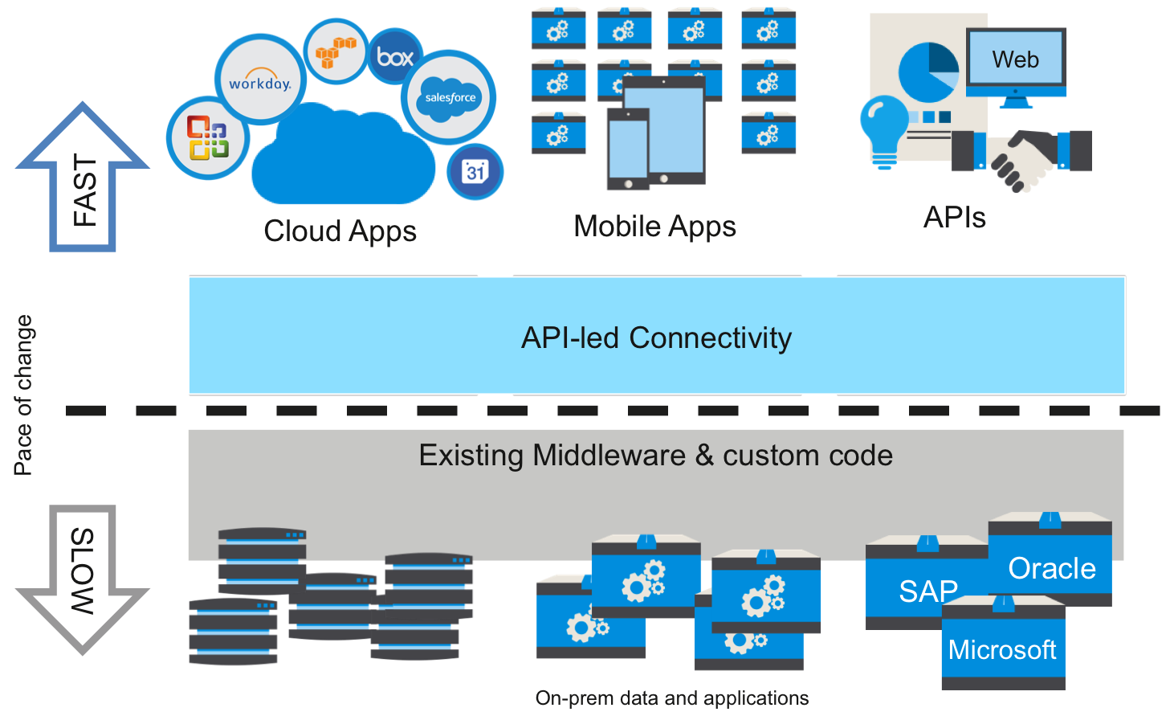  
*API-led Connectivity*

With Anypoint Platform, business users and developers can connect and access data from external sources with point-and-click simplicity. IT teams can securely expose application and data endpoints through APIs, which can be used to support development of mobile and digital apps.

## 

## 

# Mobility Delivered Through API-Led Connectivity

In this workshop, we will take a look at how the **Anypoint Platform** can be used to enable mobility through **API Led Connectivity**. We will learn how to design and implement APIs that a mobile application will use for submitting orders and checking order status, which underneath the covers, will connect to and orchestrate a variety of enterprise systems including legacy order processing databases, ERP applications, messaging queues, SaaS and cloud applications.

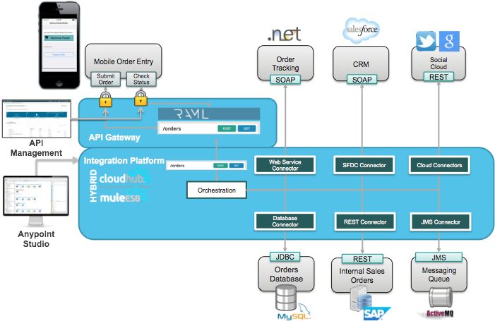

# 

# 

# Before You Begin

## General Notes

Functions or actions to be performed by you (for example, menu selections, buttons to click, ...) are for the most part in **bold**.

Text to be entered will be in a courier font

Don’t copy from a PDF! Copy form the google doc or the files on the remote desktop. Copying from a PDF sometimes brings along hidden characters or strips out special characters.

The general format for the workshop docs is to provide a screen capture of what you are doing followed by the instructions.

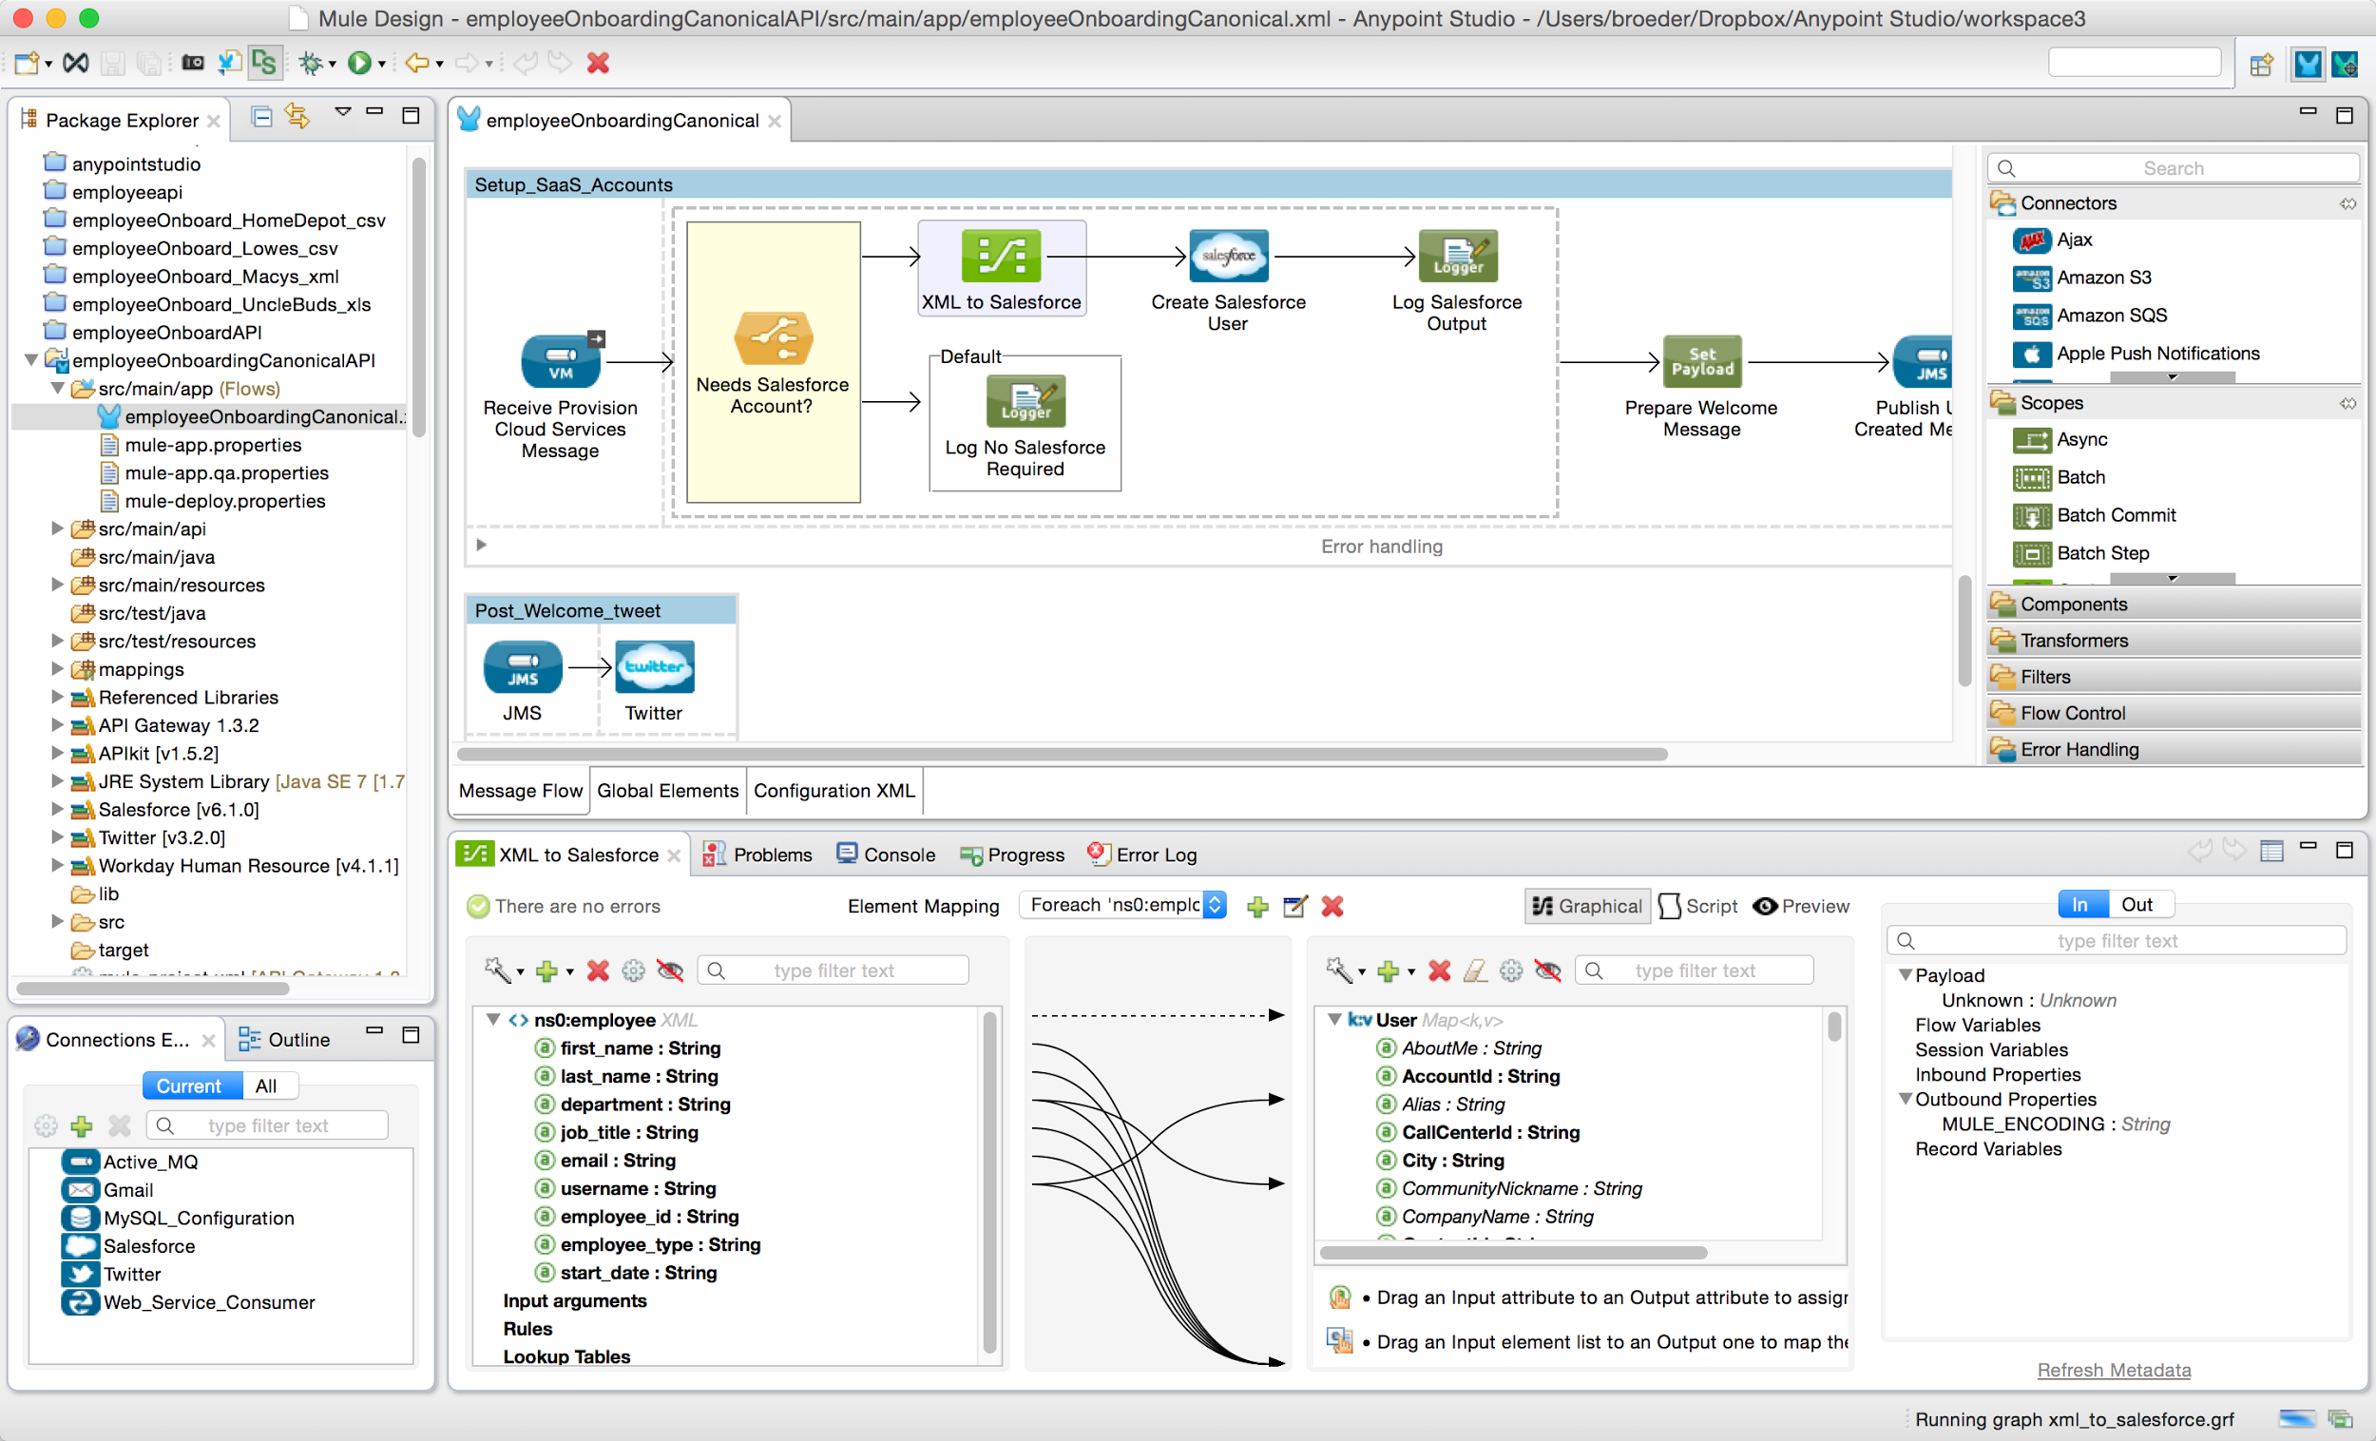

1. click on **some button**
2. enter some text
3. click **Save**
4. ...

## Connecting to your Workshop Instance

Your workshop instructor will provide each attendee with an IP address for your individual Workshop instance. Your assigned instance has been configured with the required software to complete the workshop and will run within a Windows Remote Desktop environment. To connect to your instance, launch the **Remote Desktop Connection** from your laptop.

|  |  |
| --- | --- |
| microsoft_windows_logo_3000px_by_davidm147-d3hax3m.png |  |
| Click **Start > All Programs > Accessories > Remote Desktop Connection**    In the Windows login screen, enter the username and password given to you by your instructor. Click **OK**. Click **Connect** if you get warned about a certificate. (This can be ignored). | You can install Remote Desktop Connection from the App Store.  In the *Remote Desktop Connection* screen, enter the IP address provided to you and select the **Connect** button. |

Log in to the image:

* The username is **msps**
* The password is **Anypoint1357!**

Make sure to add **:443** to your host address. Ex. **54.167.130.100:443**

You should now have a remote desktop connection to your Amazon EC2 instance. If you have problems connecting, ask your workshop instructor for assistance.

# Workshop Labs

## End to End API Management

### Lab 1: Proxy an existing API

Step 1: Create an Anypoint Platform account

Step 2: Define the Proxy

[Step 3: Test the Proxy in SOAP UI](https://docs.google.com/a/mulesoft.com/document/d/1lHlLBeonjGI8vAvuyQ3mP_maZ_n_2601XLUULSX8rP0/edit#heading=h.gbzi5w1obk6k)

### Lab 2: Manage and Consume the API

Step 1: Apply Rate Limiting Policy

Step 2: Create SLA Tiers

Step 3: Add a Rate Limiting SLA-based Policy

Step 4: Create an API Portal

Step 5: Request Access for the API

Step 6: Get Your App Credentials

Step 7: Test with SOAP UI

Step 8: Test the API with Credentials

### Lab 3: Monitor the API

Step 1: Viewing API Analytics

Step 2: Create a Custom Dashboard

## API Design First Approach

### Lab 4: Design a new API with RAML

Step 1: Design the Order Entry API using RAML

Step 2: Enable the Mocking Service

Step 3: Test the Mock Service with SOAP-UI

### Lab 5: Create an API Portal

Step 1: Create and customize the API Portal

Step 2: Manage the API Portal settings

Step 3: Adding a Getting Started Page

Step 4: Create a Notebook

### Lab 6: Generate your API Project from the RAML Design

Step 1: Export the Order Entry API RAML

Step 2: Create a new Mule Project from the RAML

Step 3: Test the API on the Mule Runtime

Step 4: Test the API from a Mobile Application

## Enterprise Connectivity and Orchestration

### Lab 7: Connect to a REST Endpoint

Step 1: Configure the RAML Consumer

Step 2: Create DataMapper transformations

Step 3: Run the API

### Lab 8: Orchestrate REST and JMS endpoints

Step 1: Configure the RAML Consumer

Step 2: Create DataMapper transformations

Step 3: Add JMS to the API

Step 4: Run the API

Step 5: Debug the API

### Lab 9: Orchestrate SOAP and Database Endpoints

Step 1: Configure the Database Connector

Step 2: Configure the SOAP Web Services Consumer

Step 3: Create DataMapper transformations

Step 4: Run and Test the API

Step 5: Test from a Mobile Application

## Hybrid Cloud Integration

### Lab 10: Connect to External SaaS and Social Networks

Step 1: Import a project from Anypoint Exchange

Step 2: Add VM connectors for asynchronous messaging

Step 3: Add the Salesforce Connector

Step 4: Run the Application

Step 5: Verify results

Step 6: Deploy to CloudHub

Step 7: Test API on CloudHub

### Lab 11: Hybrid Integration and Deployment

Step 1: Call Cloud from On-Premise

Step 2: Deploy to On-Premise Environment with MMC

Step 3: Proxy and deploy to the Cloud API Gateway

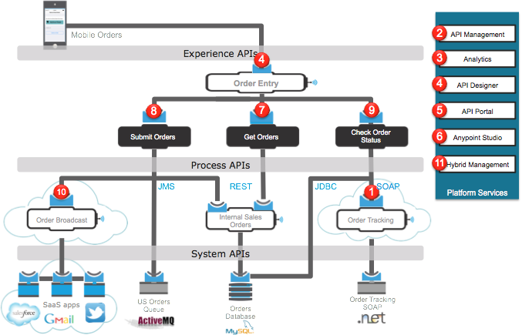

Please update the spreadsheet indicating you have successfully connected to your image with RDC.